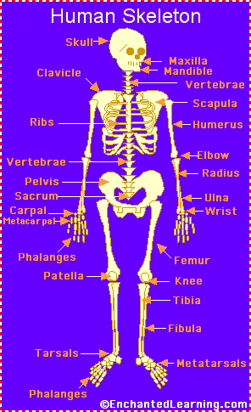
BONE IDENTIFICATION SHEET

